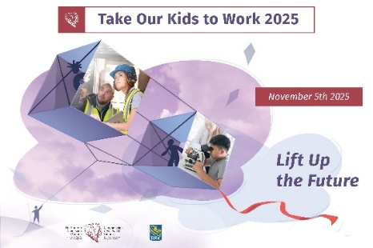
Take Our Kids to Work
Sample agenda
Time | Activity
8:15 am - 9 am | - Registration and snack table  - Icebreaker activities
9 am - 10 am | - Welcome from senior leaders  - Health and safety overview  - Participant introductions
10 am - 10:30 am | - Group picture
10:30 am - 12 pm | - THIS COULD BE YOU! Hear from employees on their roles and career paths to get there: dispatcher, service technician, truck driver, etc.  - Tour of the facility
12 pm - 1 pm | - Pizza lunch
1 pm - 2 pm | - Here’s your chance to become a real truck driver! Students get to try out the simulator
2 pm - 3 pm | - Explore a real truck! Students can see the trucks up close and go around the block with a professional driver
3 pm - 4 pm | - Job shadowing with parent/host
4 pm - 5 pm | - Closing ceremony, presentation of certificates of participation  - Refreshments

Trucking HR Canada
104-720 Belfast Rd.
Ottawa, Ontario
K1G 0Z5
613-244-4800
theteam@truckinghr.com

truckinghr.com
X-TWITTER @TruckingHR
LINKEDIN-IN @trucking-hr-canada

Copyright © 2025 Trucking Human Resources Canada

