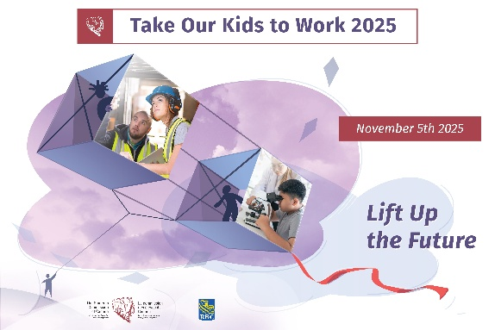
Take Our Kids to Work
Sample feedback questions
Remember to gather feedback from participants to help evaluate your program and plan for the future. It also gives participants a chance to express any concerns, praise, and make suggestions.
Questions for students:
- Who did you come to work with today?
- What was the most interesting part of the day and why?
- What was the least interesting part of the day and why?
- What’s one thing you discovered today about <name of company> that you didn’t know before?
- How did your experience today help you think about your potential careers?
- Any suggestions for how we can improve our program?
- Would you recommend this program to next year’s Grade 9 students?

Questions for parents/hosts:
- Who did you bring with you today?
- Did you learn anything new about them today?
- What did you enjoy most about the day and why?
- What did you enjoy least about the day and why?
- Any suggestions for how we can improve our program?
- Would you recommend this program to others in our organization?

Questions for non-host staff (tour guides, lunch hosts, supervisors, etc.):
- What was your role today?
- Did you have everything you needed to perform this role (clear expectations, time to prepare, space to host, etc.)?
- What did you enjoy most about your role and why?
- What did you enjoy least about your role and why?
- Any suggestions for how we can improve our program?
- Would you recommend this program to others in our organization?

Take Our Kids to Work 2025

Trucking HR Canada
104-720 Belfast Rd.
Ottawa, Ontario
K1G 0Z5
613-244-4800
theteam@truckinghr.com

truckinghr.com
X-TWITTER @TruckingHR
LINKEDIN-IN @trucking-hr-canada

Copyright © 2025 Trucking Human Resources Canada

