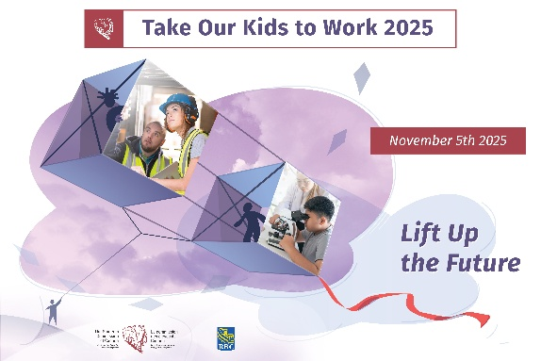
Take Our Kids to Work
Sample icebreakers
Use one or more of these activities to help start your day on a fun note.
Moving questions
This activity gives everyone a chance to briefly meet others in the group while sharing information.
- Divide the group into two (an easy way is to get everyone to count off: 1, 2, 1, 2, etc.).
- Ask the ones to form an inner circle, the twos an outer circle. Each person stands across from someone in the other circle. Each facing pair introduces themselves by name and age.
- Pose a question to the whole group and give a few minutes for the pairs to share their answers.
- Ask everyone in the inner circle to shift one place to the left. New pairs introduce themselves as above.
- Pose another question. Continue a few more times.

Up/down: What we have in common
As participants stand up or sit down in response to questions, they get to see how much they have in common — sometimes in ways they may not have guessed! Encourage them to look around while everyone is responding.
- Start with everyone sitting down.
- Share a statement and ask everyone to stand up if it’s true for them.
- Share another statement. Ask everyone to remain standing if it’s true for them, and to sit down if it isn’t. Make it more fun by asking more and more specific questions.
- Continue a few more times.
Some suggestions for statements:
- Stand up if you’ve read all The Hunger Games books or seen all the movies.
  - Stay standing if you ever dressed as a Hunger Games character for Halloween.
  - Stay standing if you won a prize for your costume.
- Stand up if you play a musical instrument.
  - Stay standing if you play the piano.
  - Stay standing if you’ve ever performed in public.

Introduce your parents
Ask the students to introduce their parents to the group, including their job and something unique about them.

Two truths and a lie
Give everyone a minute or two to write down two truths and one lie about themselves. Go around the room and give everyone a chance to read their “facts” to the group. The group has to try to guess the lie.


Trucking HR Canada
104-720 Belfast Rd.
Ottawa, Ontario
K1G 0Z5
613-244-4800
theteam@truckinghr.com

truckinghr.com
X-TWITTER @TruckingHR
LINKEDIN-IN @trucking-hr-canada

Copyright © 2025 Trucking Human Resources Canada

