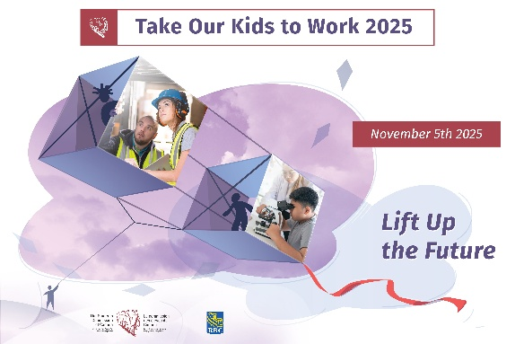
Take Our Kids to Work
Sample internal email
Use your usual internal communicaiton channles to invite staff to particpate in Take Our Kids to Work. Customize to fit your style, culture, and communication channels.

CALLING ALL EMPLOYEES WITH CHILDREN IN GRADE 9!
<Name of company> is pleased to announce our participation in the Take Our Kids to Work program on WEDNESDAY, NOVEMBER 5, 2025.
We hope you will participate by inviting your Grade 9 child to accompany you to work on that day. If you don’t have kids in grade 9, you can volunteer to host a child in need of a placement.
To participate, please register your child or host child by emailing <name of contact> with the following information by <date>:
Your name:
Department/section:
Child’s name:
Child’s school:

STAY TUNED FOR MORE DETAILS!

Trucking HR Canada
104-720 Belfast Rd.
Ottawa, Ontario
K1G 0Z5
613-244-4800
theteam@truckinghr.com

truckinghr.com
X-TWITTER @TruckingHR
LINKEDIN-IN @trucking-hr-canada

Copyright © 2025 Trucking Human Resources Canada
Trucking HR Canada
104-720 Belfast Rd.
Ottawa, Ontario
K1G 0Z5
613-244-4800
theteam@truckinghr.com

truckinghr.com
X-TWITTER @TruckingHR
LINKEDIN-IN @trucking-hr-canada

Copyright © 2025 Trucking Human Resources Canada

